

<https://citibikenyc.com/pricing>

* [How it Works](https://citibikenyc.com/how-it-works)
* [Pricing](https://citibikenyc.com/pricing)
* [Find a Bike](https://account.citibikenyc.com/map)
* [Explore NYC](https://citibikenyc.com/explore)
* [Reduced Fares](https://citibikenyc.com/community-programs/reducedfare)

[Log In**Join**](https://account.citibikenyc.com/login)

* [DAY PASSES](https://citibikenyc.com/pricing/day)

**Choose your plan**

**Annual Membership**

**$15*/month**

unlimited 45-minute rides on a classic bike.

[**[Join now]**](https://account.citibikenyc.com/login)

*$185 billed upfront annually

**Single Ride**

**$3.99/trip**

one ride up to 30 minutes on a classic bike.

[**Get a pass**](https://citibikenyc.com/pricing/single-ride)

**Day Pass**

**$15/day**

unlimited 30-minute rides in a 24-hour period on a classic bike.

[**Get a pass**](https://citibikenyc.com/pricing/day)

**Plan details**

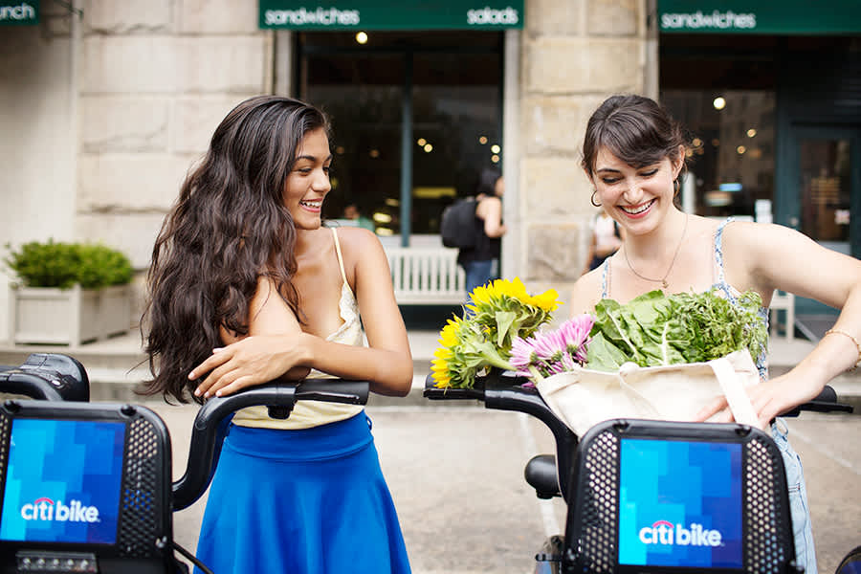

**Annual Membership**

**Best deal for NYC locals.**

The annual membership is just $15/month ($185 billed upfront annually). It includes unlimited 45-minute rides on a classic Citi Bike. Upgrade to an ebike for an extra $0.15/minute, capped at $3 for rides 45 minutes or less that start or end outside Manhattan. If you keep a bike out for more than 45 minutes, regardless of the type or destination, it’s $0.15 per minute.

[**Learn More**](https://citibikenyc.com/pricing/annual)

**Day Pass**

**Perfect for visitors or Tourists.**

The day pass costs $15 for a 24-hour period. The first 30 minutes of each ride on a classic Citi Bike are included in the price of the pass, and you can take as many rides as you want while your pass is active. Upgrade to an ebike for an extra $0.23/minute. If you keep a bike out for more than 30 minutes at a time, it’s an extra $4 per additional 15 minutes.

[**Learn More**](https://citibikenyc.com/pricing/day)

**Single Ride**

**Great for quick trips.**

A Single Ride is just $3.99 and includes the first 30 minutes of one ride on a classic Citi Bike. When you upgrade to an ebike, it will be an extra $0.23/min. If you keep a bike out for longer than 30 minutes at a time, regardless of the type, it's $0.23 per minute.

[**Learn More**](https://citibikenyc.com/pricing/single-ride)

© Lyft, Inc. 2022  
  
Citi Bike, Citi Bike and Arc Design and the Blue Wave are registered service marks of Citigroup Inc.  
  
We at Citi Bike strive to provide access to our services to all individuals, including through an accessible website. If you have questions, comments, or encounter any difficulty in using this site, please submit feedback via: [citibikenyc.com/accessibility-feedback](https://citibikenyc.com/accessibility-feedback)